# Week 10 Lecture Notes

**Online Revenue Models – Google Case Study**

(Chapter 16 in version 3 | Chapter 18 in version 7)

1. Understand the shift to online advertising
2. Understand the Google search mechanism
3. Understand Google’s search advertising model and the cost structure
4. Understand how to make money from Google Ads
5. Understand privacy issues and ethics related to tracking and collecting user information

## Understand the shift to online advertising

Google is one of the most influential and profitable companies in modern times. It’s a dynamic and innovative company that operates in many business sectors including media, technology, and healthcare. Google has evolved into Alphabet, a diverse holding company investing in a wide-ranging array of potentially high-impact endeavors.

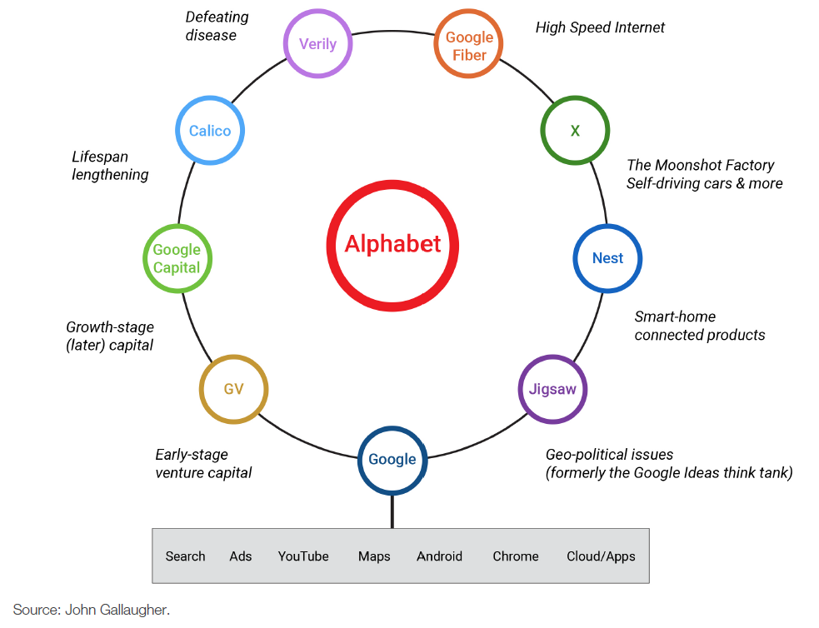

Google pairs Internet surfers with advertisers. The majority of Google’s revenue comes from online advertising which they have mastered and turned into a source of competitive advantage. Google controls a third of all online advertising and its search capabilities have turned it into one of the strongest brands in the world, with the company name used as a verb to describe the act of searching for information online (“Google it”).

**Why the Increase in Online Ad Spending?**

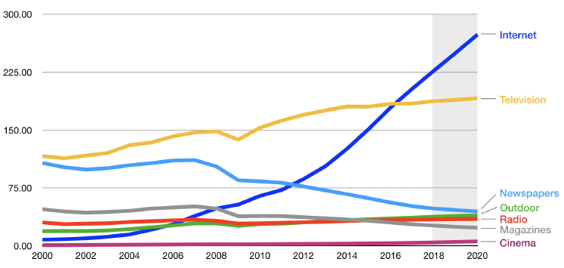

**Source: Data from Zenith via R. Molla, “Advertisers will spend $40 billion more on Internet ads than on TV ads this year,” Recode, March 26, 2018,** [**https://www.recode.net/2018/3/26/17163852/online-internet-advertisers-outspend-tv-ads-advertisers-social-video-mobile-40-billion-2018**](https://www.recode.net/2018/3/26/17163852/online-internet-advertisers-outspend-tv-ads-advertisers-social-video-mobile-40-billion-2018)

**(1) increased user time online**

Online advertising has grown steadily over the last decade as people spend more time online and on various devices. This has led to a shift of spending to online adverts from traditional adverts such as TV, billboards and printed media.

**(2) improved measurement and accountability**

Return on Investments and the impact of traditional advertising is difficult to measure. Can a company tell the number of people that view their billboards daily? Can the number of viewers who see a TV ad be linked back to number of sales of an item?

Online advertising offers different tools and techniques for measuring ad success and linking ads to product sales.

**(3) targeting**

Online advertising allows targeted ads that will only be displayed to relevant viewers based on criteria selected by the advertiser. This leads to increased sales based on precision of the ads.

## Understand the Google search mechanism

Google handles an average of 40 million searches per second. When you search on Google or other search engines, the results displayed is known as “organic or natural search”. These results are displayed and ranked according to relevance and different search companies determine relevance using different algorithms. Google uses the PageRank algorithm which displays web pages based on popularity and determined by the number of pages that link to the web page listed. Google is not specific about how exactly the PageRank algorithm works but in addition to in-bound links, Google’s organic search results also consider some two hundred other factors.

Web searches are done by spiders, web crawlers and software robots whichtraverse available websites to perform a given task. Spiders discover documents for indexing and retrieval.

See Section “Spiders and Bots and Crawlers—Oh My!” for more details on web searching.

## Understand Google’s search advertising model and the cost structure

Majority of Google’s ad revenue comes from ads displayed on its search engine. Google provides text, image and video ads. These ads are based on keywords used in the user’s search query, so whatever keyword you enter in the search bar, the ads displayed will always be related to it. These targeted advertising makes Google ads highly valuable. Advertisers bid on the keywords and phrases used to trigger the ad.

Ads are priced on a pay-per-click basis where advertisers do not pay unless someone clicks. To ensure ads are relevant to users, and profitable to both Google and advertisers, Google developed a precise ad ranking formula that rewards top performing ads by:

* Maximum CPC (cost-per-click) an advertiser is willing to pay.
* Advertisement’s quality score.
* and ad formats

Some factors that affect an ad’s quality score are:

* click-through rate (CTR): Number of users who clicked an ad divided by the number of times the ad was delivered.
* Overall history of click performance for the keywords linked to the ad.
* Relevance of an ad’s text to the user’s query.
* Automated assessment of the user experience on the landing page.

Google provides support for advertisers in many ways including:

* Google provides tools to identify popular words and phrases for selecting keywords to link with an ad.
* Offers dynamic search ads which generated automatically based on the content of a website. This helps advertisers with rapidly changing content or advertisers who need a wide range of search terms.
* Advertisers get a running total of ad performance statistics that helps:
  + Monitor the return on their investment.
  + Tweak promotional efforts for better results.

Ad ranking and cost-per-click calculations take place as part of an automated auction that occurs every time a user conducts a search.

**Cost structure**

Pricing is based industry and current competition for the ad space. The price will reflect what other advertisers are willing to pay. The table below shows the keywords with the highest pay per click prices in June 2014.

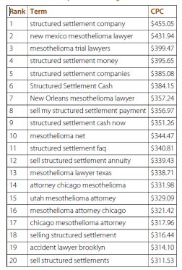

**Targeting by Location**

Geotargeting occurs when computer systems identify a user’s physical location for the purpose of delivering tailored ads or other content. The advertiser can specify locations where the ads can be viewed while setting up the ad using Google AdWords. Most locations are based on the IP address of the device being used. Geotargeting using IP addresses is not always accurate because IP addresses can be based on defaults set up by Internet Service Providers. To overcome this issue of accuracy, Google can identify a location based on mapping Wi-Fi hotspots and nearby cell towers and mobile phone GPS.

## Understand how to make money from Google Ads

Google’s AdSense enables individuals and companies host ads on their websites and get paid for it. Google lines up the advertisers, provides the targeting technology, serves the ads, and handles advertiser payment collection. Interested parties sign up online and then embed HTML code from Google into their website. AdSense uses keyword targeted advertising to display adverts on a website. The keywords are based on content on the web page or by targeted criteria such as location.

Google AdSense contributes to their competitive advantage in the following ways:

* Ability to reach more potential customers attracts more advertisers.
* Content providers look for ad networks with the most advertisers.
* More participants bring in more revenue and help the firm benefit from scale economies.
* Better return on investment from its ad technology and infrastructure.

One challenge of AdSense is content adjacency problems which is a situation where ads appear alongside text the advertiser would like to avoid. To combat embarrassment, ad networks provide opportunities for both advertisers and content providers to screen out potentially undesirable pairings based on factors like vendor, website, and category. Advertisers can also use negative keywords, which tell networks to avoid showing ads when specific words appear.

## Understand privacy issues and ethics related to tracking and collecting user information

Mishandled user privacy could curtail targeting online advertising and result in negative backlash from users.

Google features that cater to privacy concerns allow users to:

* See all the categorisations assigned to a browser’s tracking cookie.
* Remove categorisations or add interests to improve ad targeting.
* Install a cookie or plug-in that opts them out of interest-based tracking.
  + opt-out: Enroll all customers by default but allow them to discontinue participation if they want to.
  + plug-in: Extends the feature set or capabilities of another application.

There are concerns over what users see as the increasing amount of information that Google houses. Google insists that reports portraying it as a “data-hoarding Big Brother” are inaccurate and user data is not sold to third parties. Any targeting is fully disclosed, with users empowered to opt out at all levels. Google unified its privacy policy in a way that allows for greater profiling, sharing, and tailored services across Google offerings.

Privacy advocates also worry that the amount of data stored by Google serves as one-stop shopping for litigators and government investigators. Google has continually shown an aggressive defence of data privacy in court cases.  Google is increasingly finding itself in precedent-setting cases where the law is vague. Google is now taking a more active public relations and lobbying role to prevent misperceptions about its data policies and to be sure its positions are understood.